CMake Project.

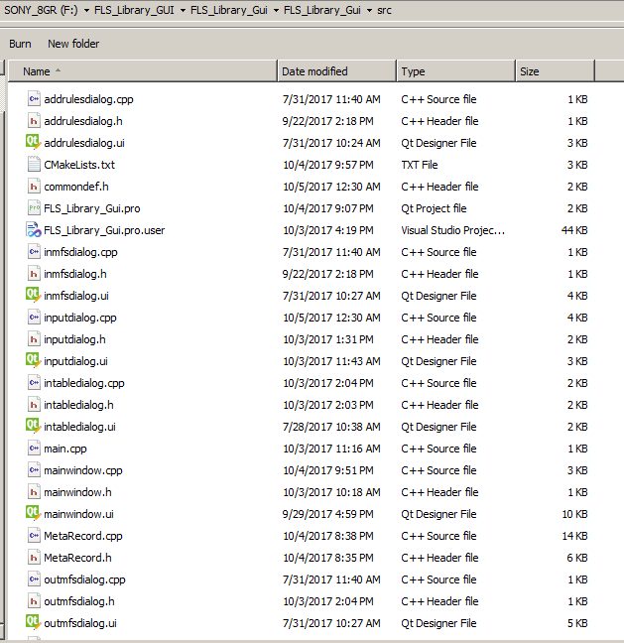

Copy the folder path.

Example : D:/________w/bu/FLS_Library_GUI/FLS_Library_Gui/FLS_Library_Gui/src

Configure the paths as shown in the image.

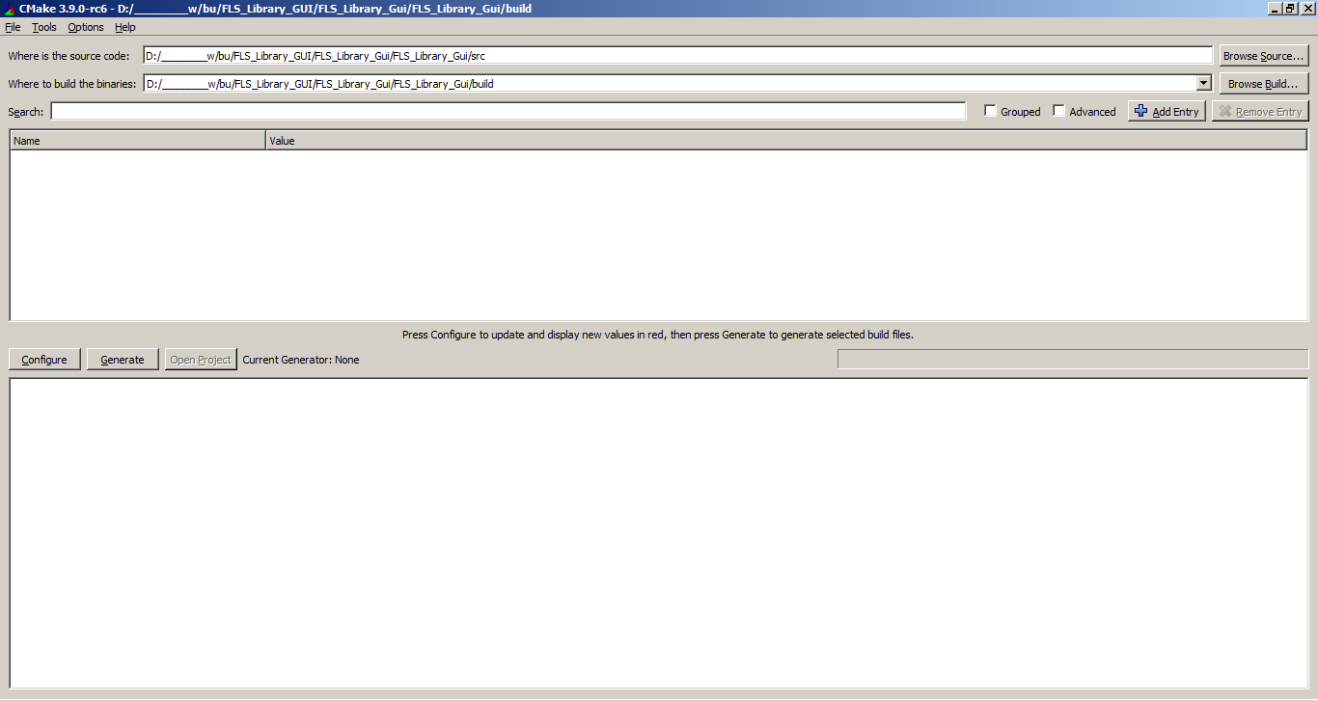

Press configure.and press yes to create a folder if the build folder is not available.

Then a dialog will popup like this.

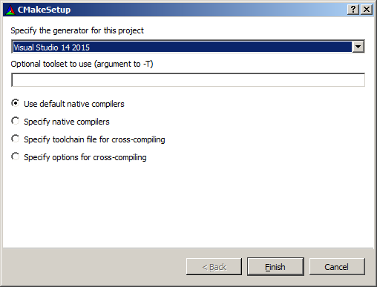

Select the compiler from the list of compilers available. I am using visual studio 2015 compiler. Press Next.

Usually the cmake will identify the Qt location. If not, then provide the qt location as follows. If you get an error that qt is not found, specify the folder in Qt.

Eg. C:/Qt/5.9.2/msvc2017/lib/cmake/qt5

C:\Qt\5.9.2\msvc2017_64\lib\cmake\Qt5

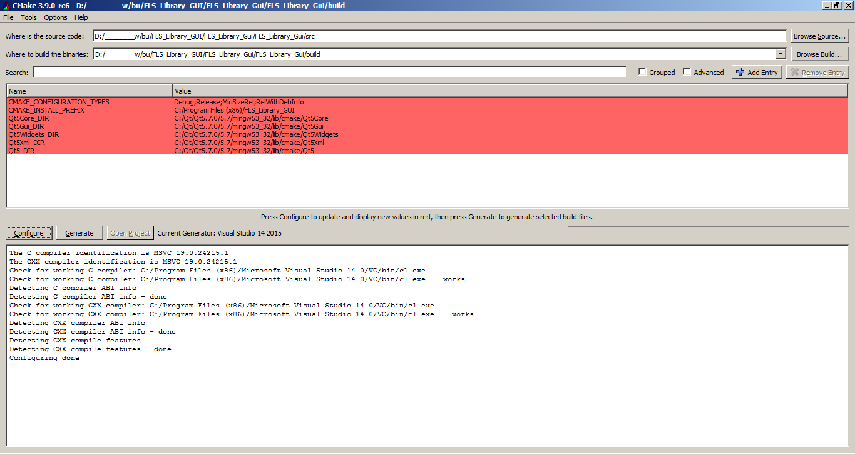

Press the generate button and once generation is done, then press open project.

The project will be opened in visual studio and the same can be builded there.

If there is an error because of target system as x86 or x64, clear cache of cmake (File-> delete cache) and configure cmake for your system compiler.

Cmake can be downloaded from

<https://cmake.org/download/>

If you have a error with access is denied, go to VS Solution Explorer Window, right click "Executables " and select ""Set as StartUp Project".

Save the reqiured dll libraries at the debug folder. Make sure the libraries are from the qt version that you have installed it for.

Example Folder: C:\Users\Abel\Transporter\Transporter\Abel Hailemichael\Workspace\FLS Library\FLS_Library_workspace\build\Debug